


Humana Story Sync from Azure to Copado



Document Control Information
Document Information
Document Name | Humana Story Sync from Azure to Copado
Project Name | Humana Salesforce DevOps
Client | Humana
Document Author | Jeremy Thiede
Document Version | 1.0
Document Status | Release
Date Released | 6/5/2020
Document Edit History
Version | Date | Additions/Modifications | Prepared/Revised by
Document Review/Approval History
Date | Name | Organization/Title | Comments

Table of Contents
1 Overview 4
Audience 4
Purpose 4
Assumptions 4
2 Story Sync Overview 5
3 Setup a Sync from Azure to Copado 6
3.1.1 Setting Up a Named Credential 6
3.1.2 Setting Up a Copado Integration Settings 7
3.1.3 A Query in Azure 8
3.1.4 Setting Up a Project in Copado 8
3.1.5 Setting up Field Mappings 10
3.1.6 Setting Up Copado to Update Azure Kanban Columns 10

Overview

Audience
The intended audiences are technical designers and developers of the Salesforce.com application. ‘Developers’ include anyone who make modifications to the Salesforce.com Application Setup and is not isolated to developers working on implementing a single project.

Purpose
The Purpose of this document is to outline the capabilities and how to setup the User Story Sync between Azure and Copado (for Salesforce).

Assumptions
The reader of this document has experience in Apex and Visualforce development. The reader also has basic knowledge of the Salesforce platform.
It is also assumed that the reader has exhausted their resources to determine if a reasonable solution can (or should) be implemented by adhering to the standard out of the box functionality that Salesforce.com supports.

Story Sync Overview

The out of the box functionality moves stories from Azure to Copado. This process is kicked off in Copado on the Project tab under the Copado Developer app. When selecting a Project, there is either a button or a link from a drop down entitled ‘Sync External User Stories’. This will make a call out to Azure based on a query set up in Azure and some additional settings in Copado. Copado will fetch some JSON from Azure based on the settings in Copado to be brought over, this sync will only occur for the selected project and the stories will be created and assigned to that project.
Conversely, for a story to be updated in Azure, a User Story is selected and the ‘Status’ field changes and the User Story is saved. At this point, a Salesforce Process Builder is invoked and makes a call out to Azure updating the fields which are setup in Copado to be sunk up.
The Future state of the Story Sync has some modifications to ensure a more integrated design. The sync from Azure to Copado will be a scheduled job which is set to run once a day (currently 11pm eastern) and handles all Projects in the status of ‘In Progress’. For anyone needing to access stories sooner, those individuals may contact their DevOps team to manually push the button as described above.
For a story to sync back to Azure, the call out will occur when the ‘Org Credential’ is changed on the User Story in Copado - this will happen for all configurations. If a Project team desires, there is an ability to update Azure with the environment that a story has moved to. This requires some additional settings to be described later.

Setup a Sync from Azure to Copado
In order to setup a sync from Azure to Copado, there are a couple of things that need to occur.
- First a ‘Named Credential’ must exist in Salesforce for the main connection to the Azure Cloud Server. This traditionally is a service account and has been setup by E3 already.
- Next, a ‘Copado Integration Setting’ which uses the ‘Name Credential from above.
- A query in Azure must be created which will yield the results of the stories to bring over.
- Once the query is created, there will be a guid that appears in the URL for the query. This guid is used as the ‘Workspace ID’ on the Copado Project record.
- In addition to the ‘Workspace ID’, the ‘Project External ID’ is needed for the Copado Project Record. This can also be found in the Azure query URL. The sync will not work if these fields are blank on a project record in Copado.
- A ‘Project’ is created using the ‘Copado Integration Setting’, the project name, and the guid from the query in azure.
- After saving the ‘Copado Project’ record, the last step to getting your project ready to sync is to setup up some ‘Field Mappings’.

Setting Up a Named Credential
In order to setup a named credential, you must have rights to create one in Salesforce. To create one, go to ‘Setup’ by clicking on the gear icon. If you do not have the gear Icon you will need elevated permissions in Salesforce.
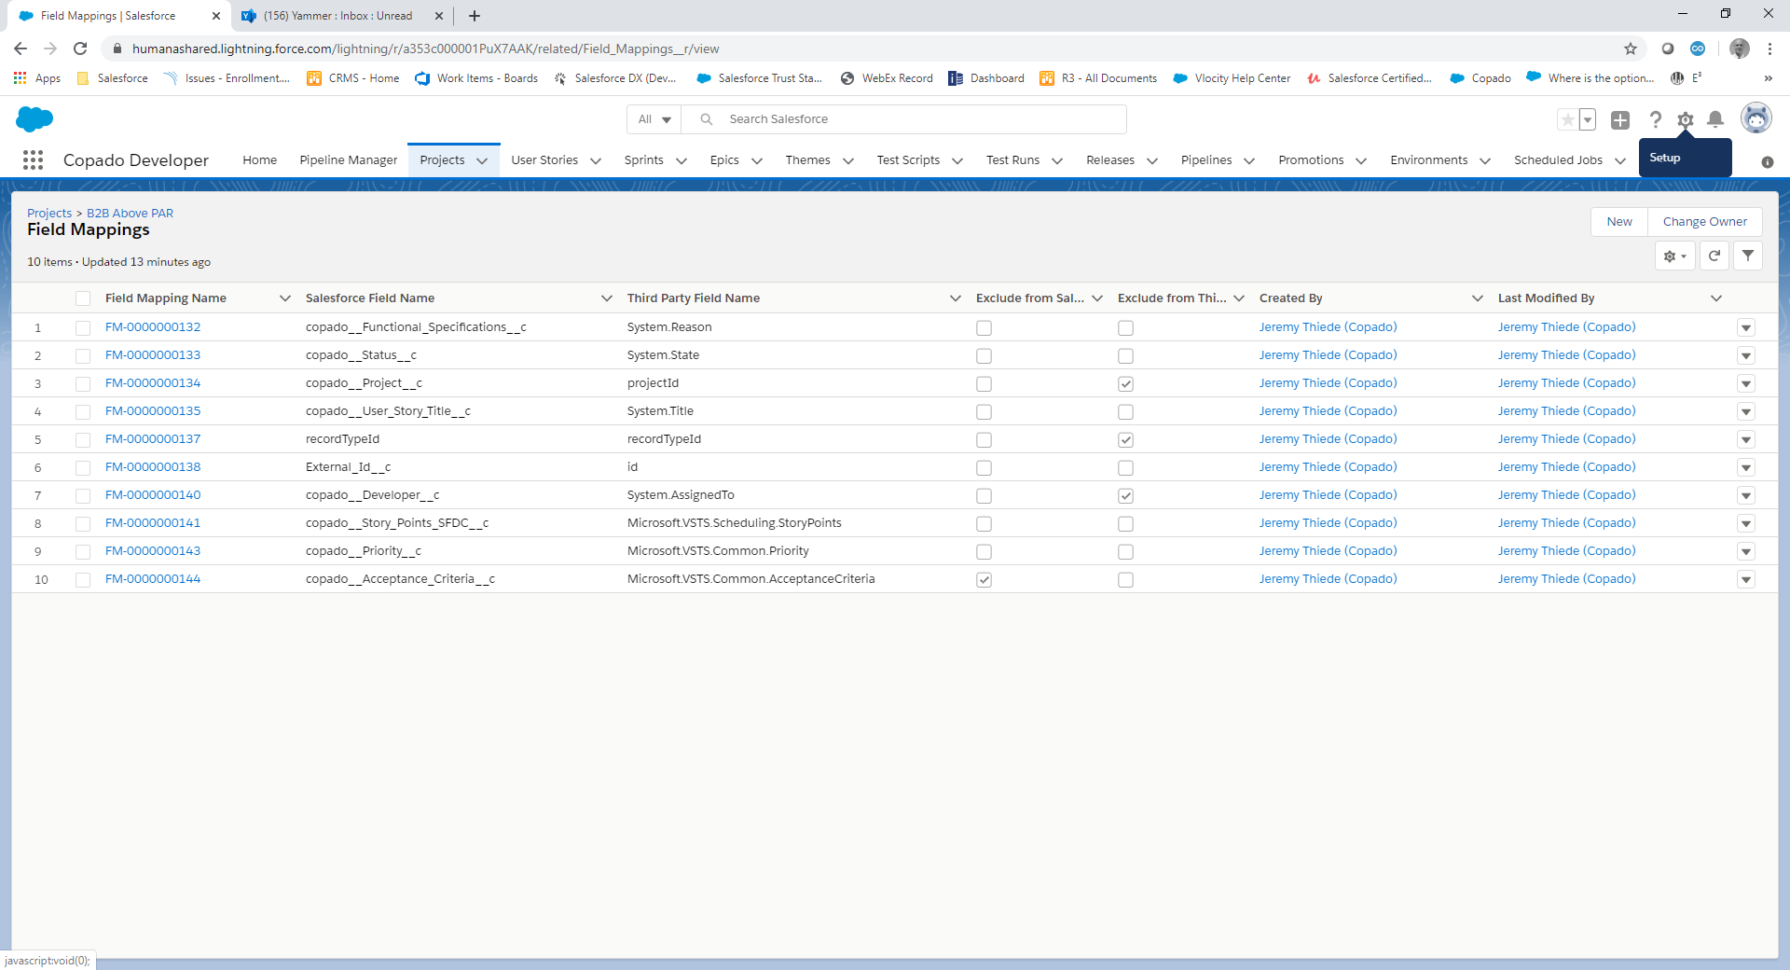

Once in ‘Setup’, enter the word ‘named’ in the ‘Quick Find’ search bar. This will filter the settings down and present you with the option of ‘Named Credentials’. Select ‘Named Credentials’ to continue.
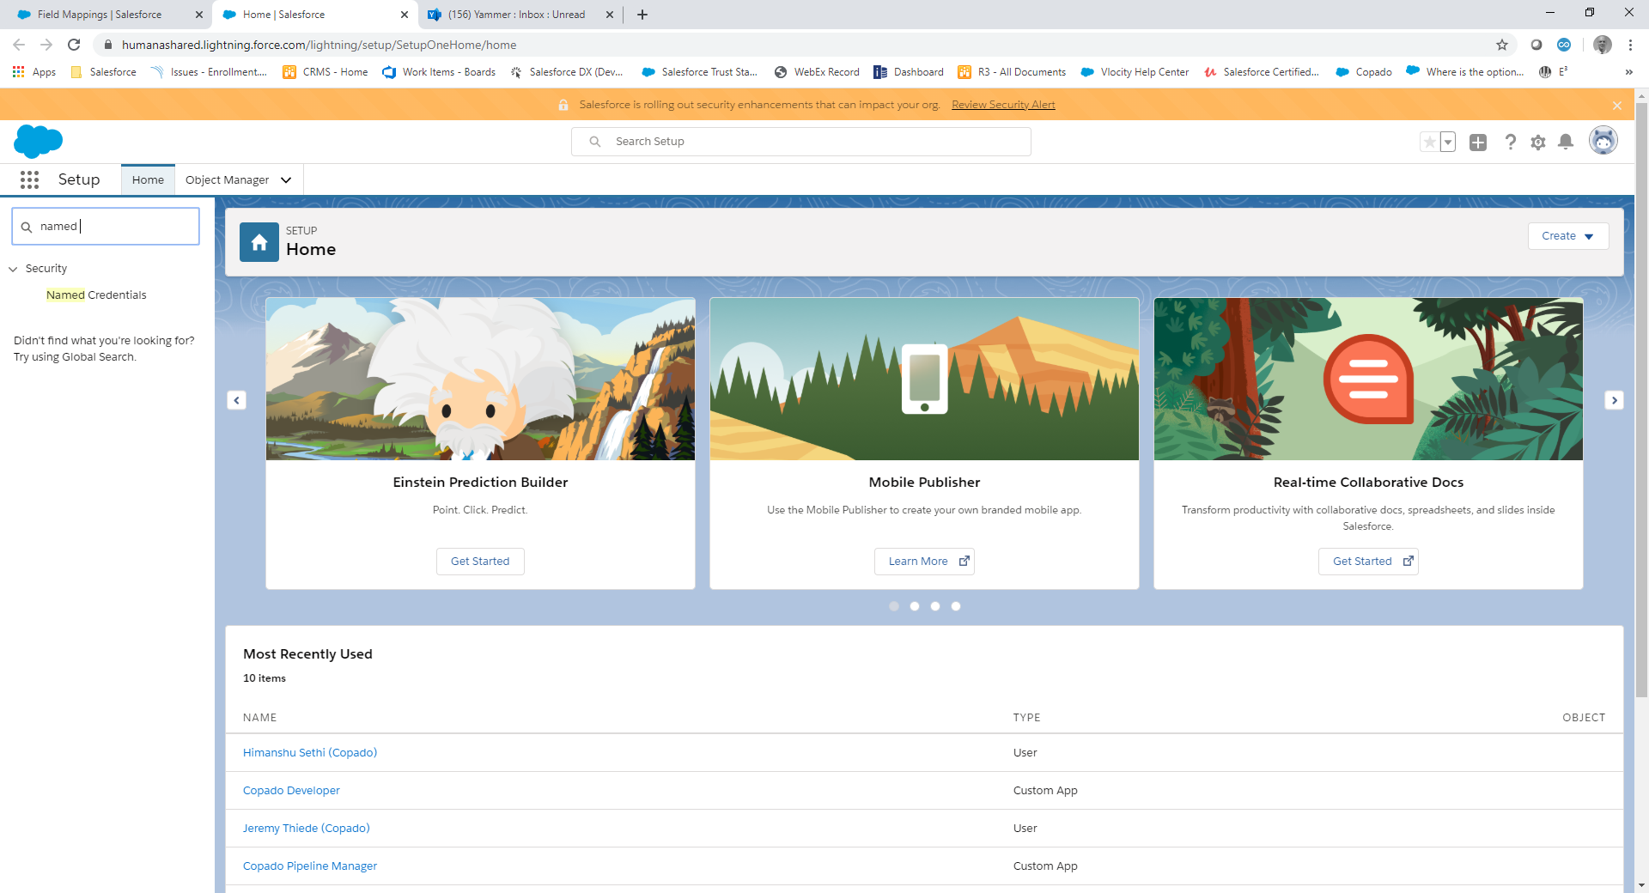
You will be taken to a list view that shows other credentials if setup:
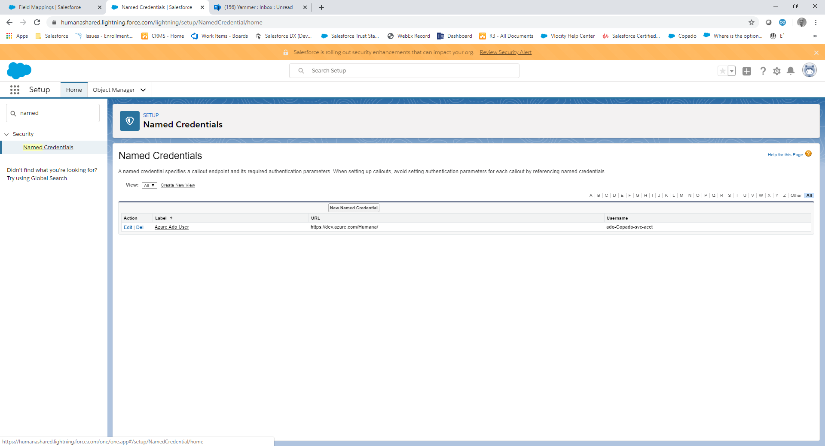

In the example above, there is one other credential setup. If this is correct, make note of the name and proceed to the next section entitled ‘Setting up a Copado Integration Settings’. If you do not see what you need, click on the button ‘New Named Credential’.
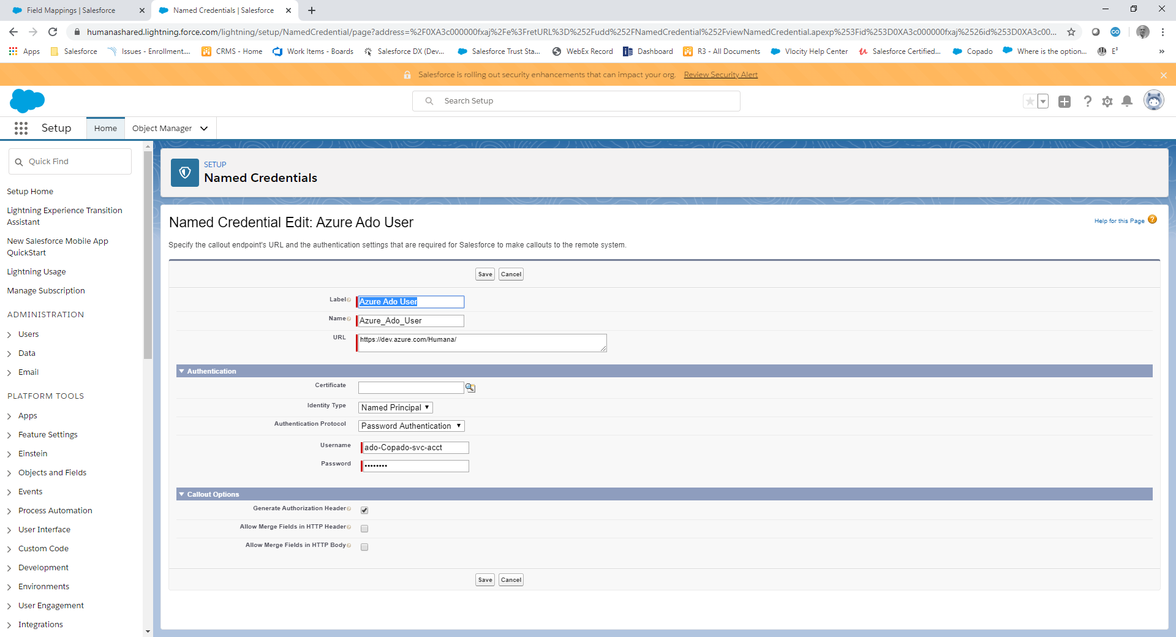

Enter the values needed and click ‘Save’. Make sure to take note of the name or copy it so you can use it for the next step.

Setting Up a Copado Integration Settings
Do a search for Copado Integration Settings in the App Launcher (the nine little dots icon):
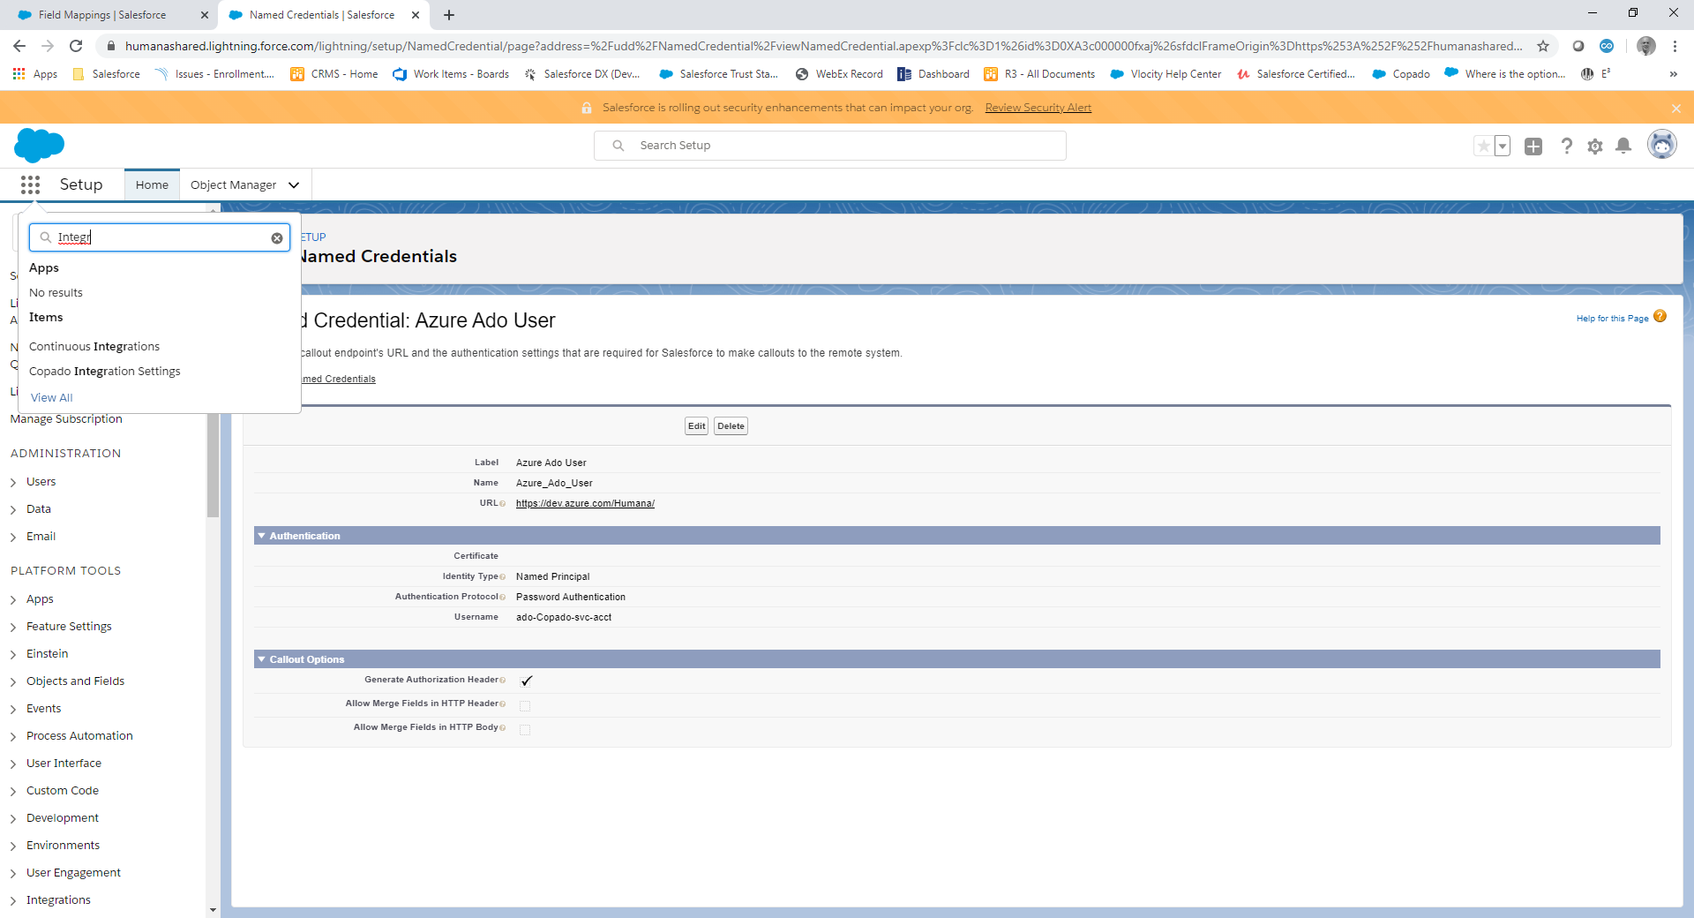

Click on Copado Integration Settings and you will see a list view again. If there is an existing one, than most likely that has already been setup. If not, click on ‘New’. You will be presented with the following screen. Enter the ‘Copado Integration Setting Name’, select ‘Visual Studio Team Services’ and enter or paste the name of the ‘Named Credential’ you setup/found in the last section. Click on ‘Save’.
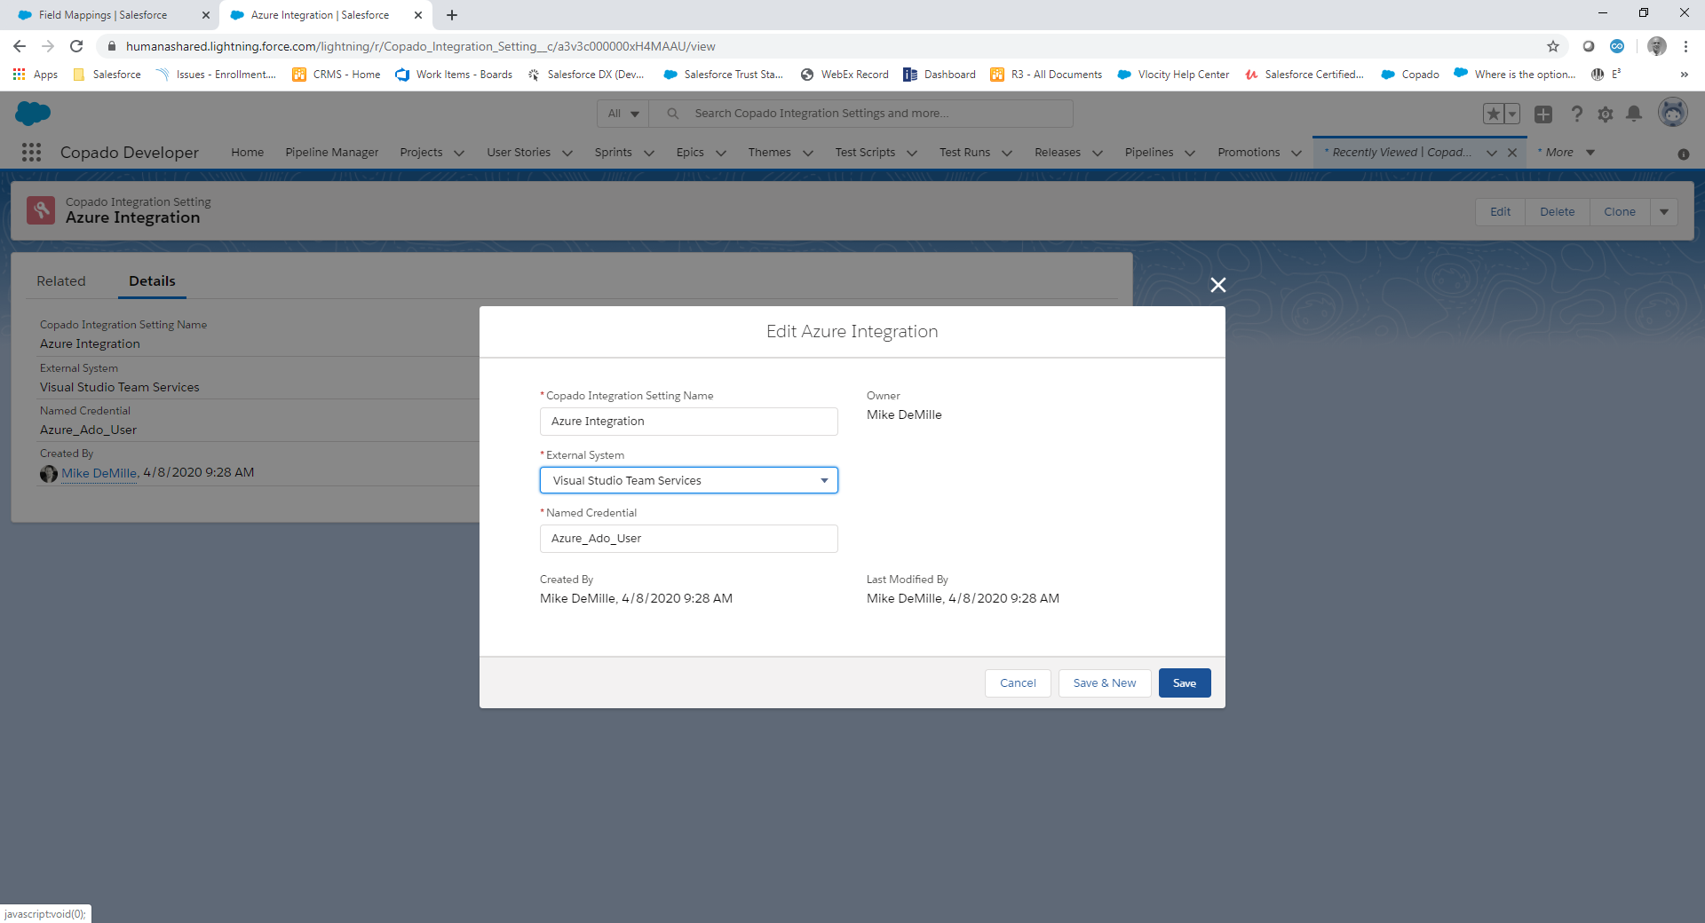

A Query in Azure
In order to sync up stories to Copado, a query needs be created in Azure. The setting up of Azure is outside of the scope of this document. Here is an example of a query URL created in Azure:
https://humana.visualstudio.com/B2B%20Salesforce/_queries/query/83fb68c9-cf69-4e6d-b2b2-7d7777f07062/
The portion in the highlighted yellow is what Copado considers the ‘Project External ID’ and the green highlighted text is the guid which is considered the Copado ‘Workspace ID’.

Setting Up a Project in Copado
In the app launcher type ‘Copado Developer’ and select it. Click on the ‘Projects’ tab to continue.
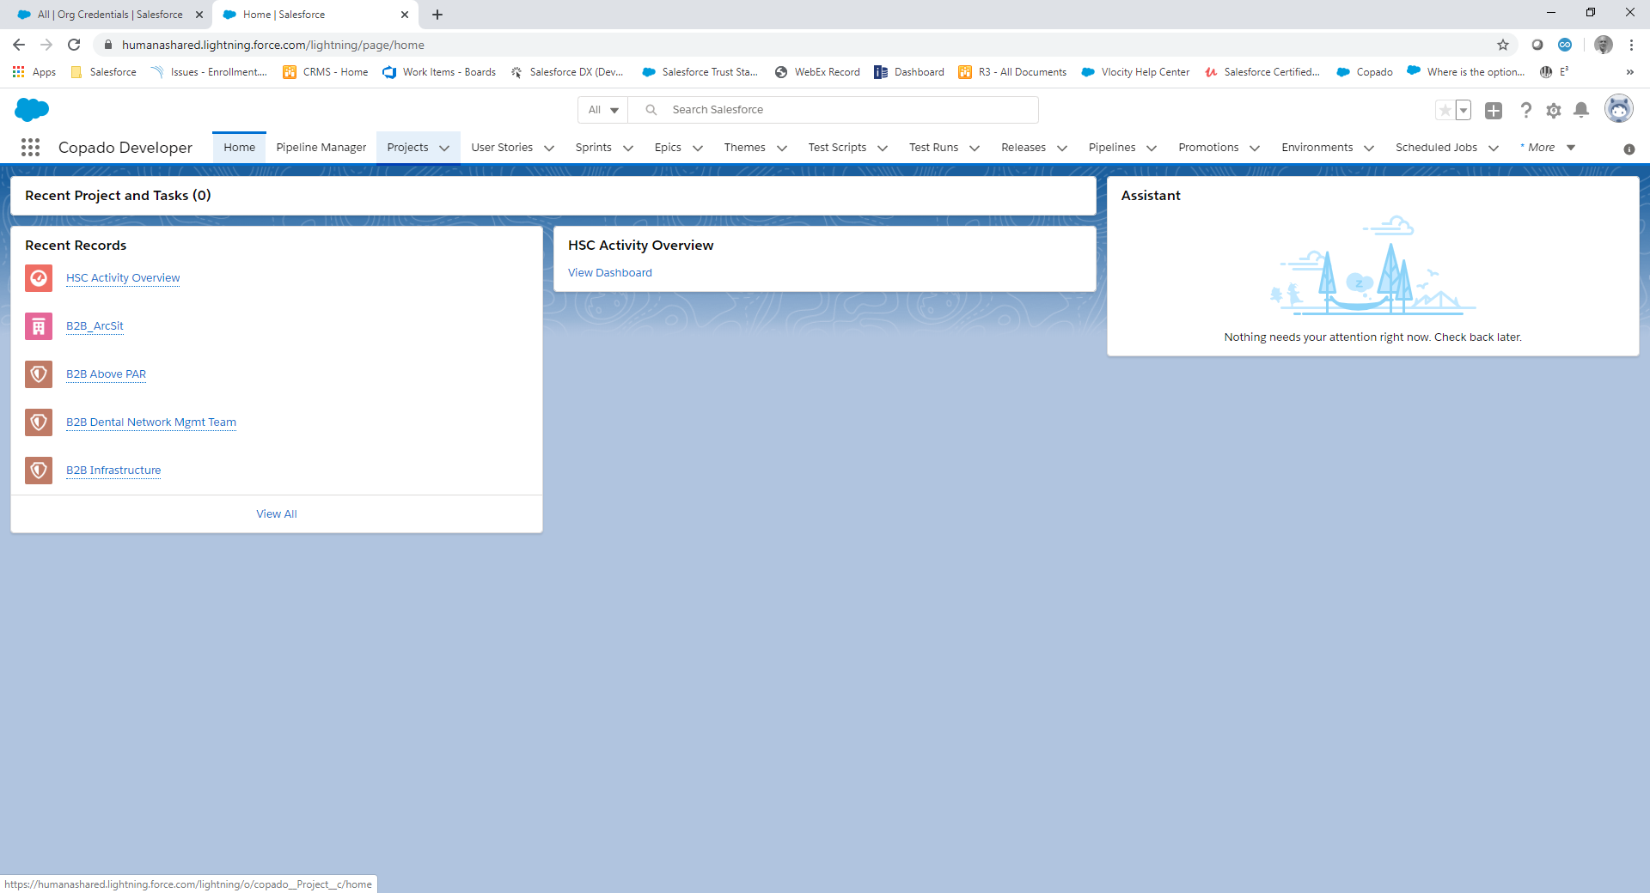

To create a new ‘Project’ click on the ‘New’ button.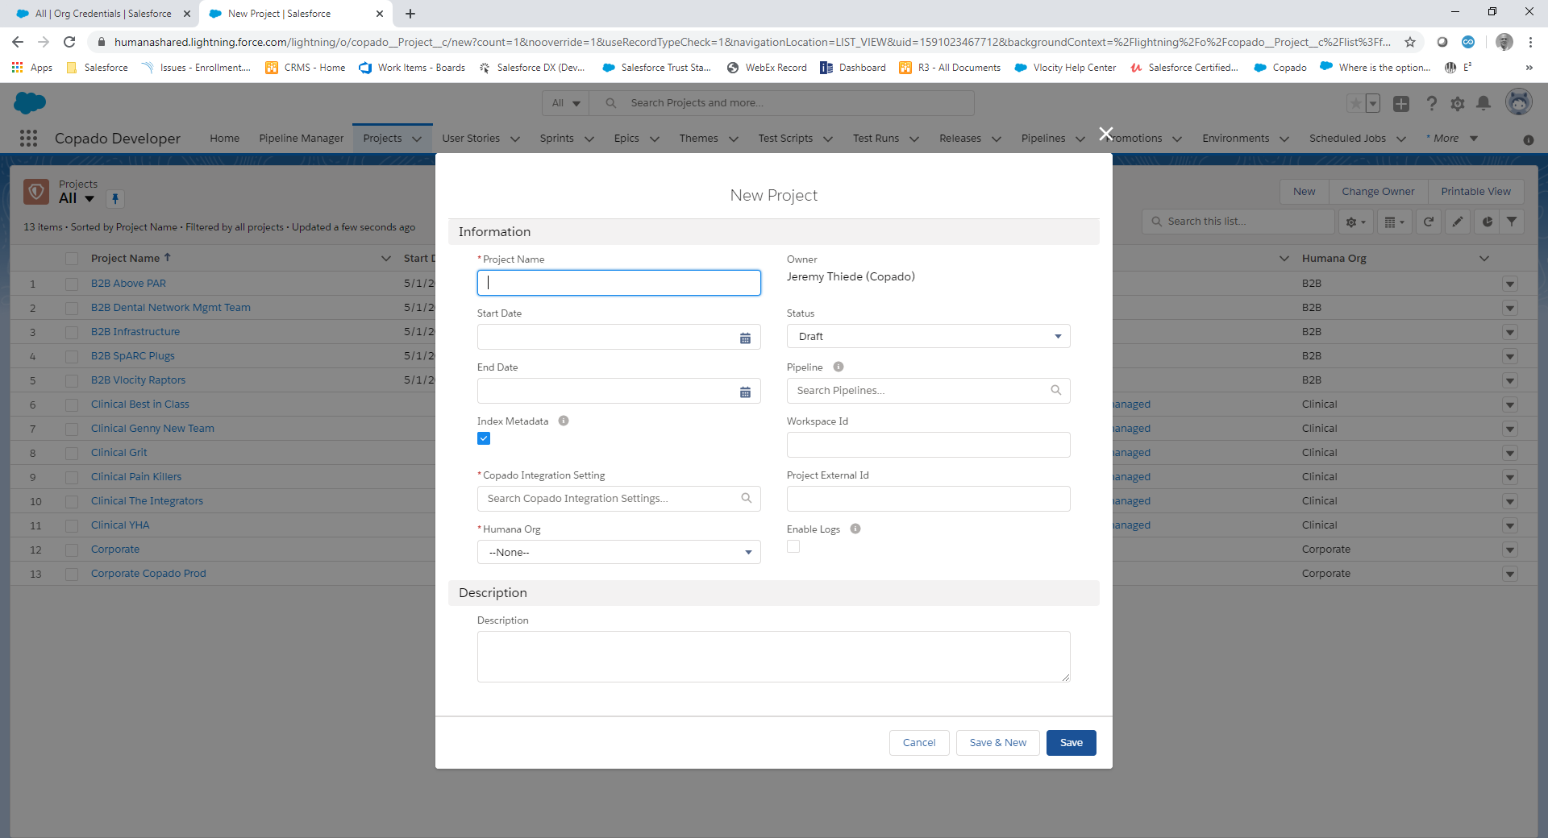
- Enter the name of the ‘Project’; Scrum Names have been used in the past to differentiate stories and settings. This allows different fields to be setup for mappings from Azure to Copado.
- A ‘Start Date’ and ‘End Date’ are not mandatory, but for B2B, ten years was used to set these values (i.e. 5/1/2020 to 5/1/2030).
- Set the ‘Status’ field to ‘In Progress’.
- For ‘Pipeline’, select the name of the pipeline which has been setup already.
- ‘Index Metadata’ is checked by default, it is recommended to keep as checked.
- Enter the ‘Workspace ID’ from the query that you setup for this project or scrum team in Azure.
- Search and select the Copado Integration Setting Name (which was setup in a prior section).
- Enter the ‘Project External ID’ from the query that you setup in Azure.
- ‘Humana Org’ should be set and is the name of the business unit that this project is from.
- ‘Enable Logs’ is used for some debugging and is not typically necessary.
- ‘Description’ is a free form field and is optional.
Click ‘Save’ when completed.

Setting up Field Mappings
After saving your newly created project, you can select the project by clicking on it in the list view.
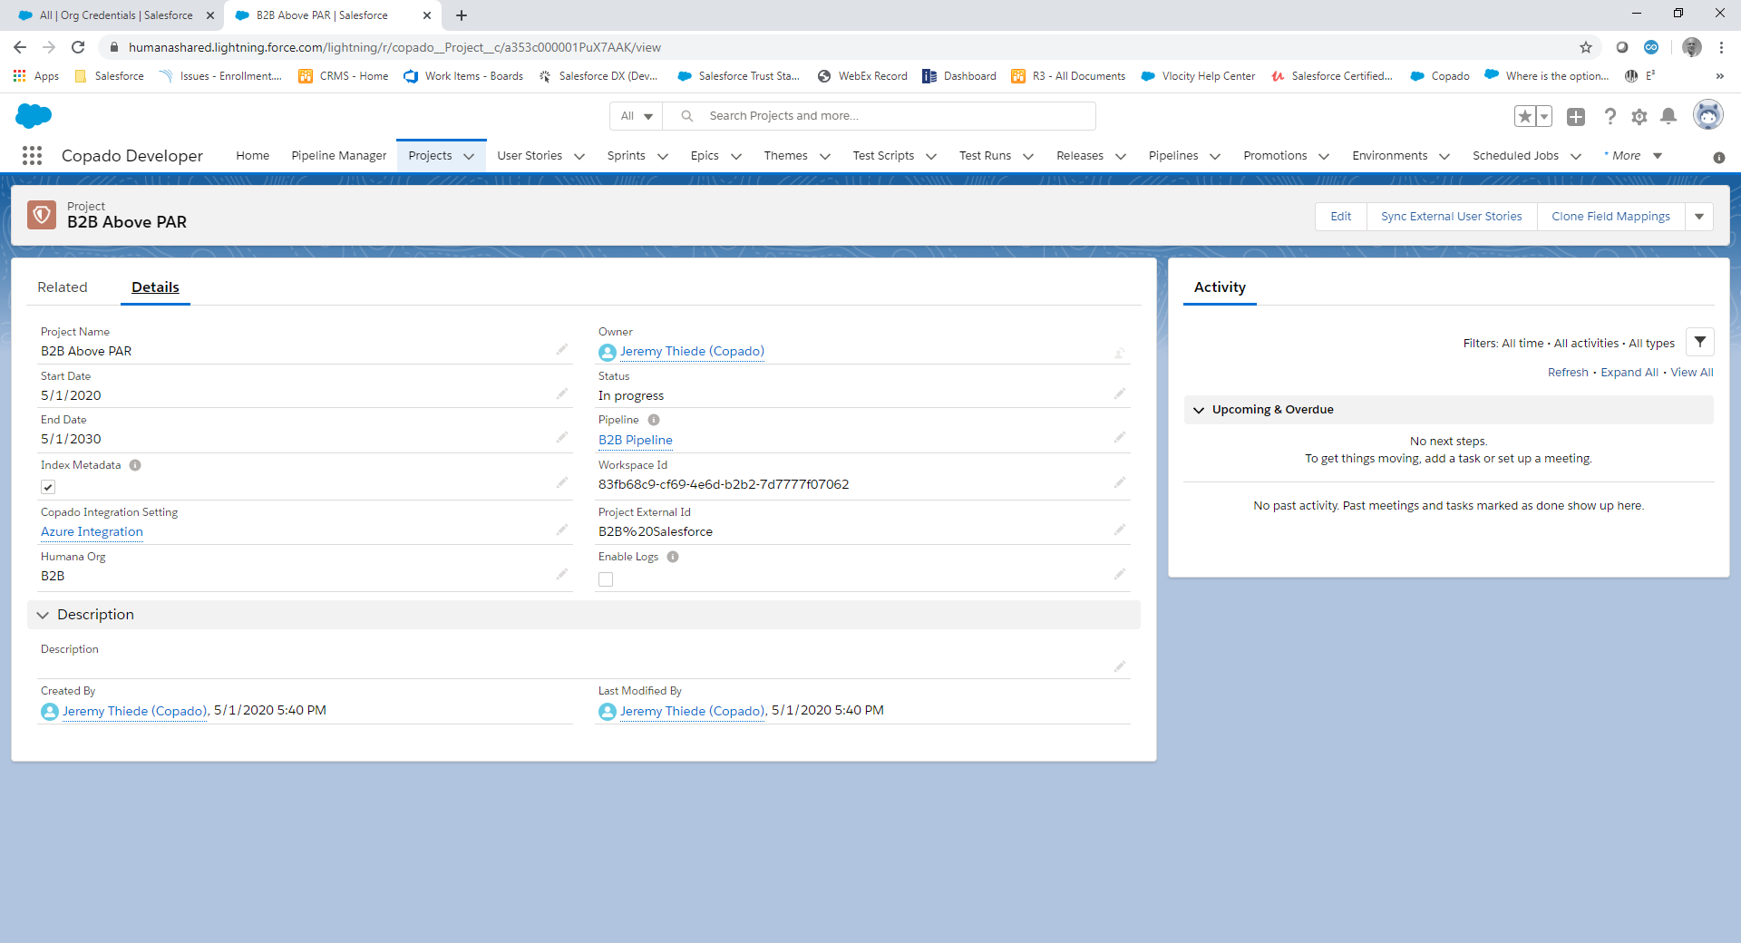
One way to create field mappings is by selecting the ‘Clone Field Mappings’ button which will copy the ‘Field Mappings’ from a project which was already setup. If a previous project was not setup,
The following image can be used:
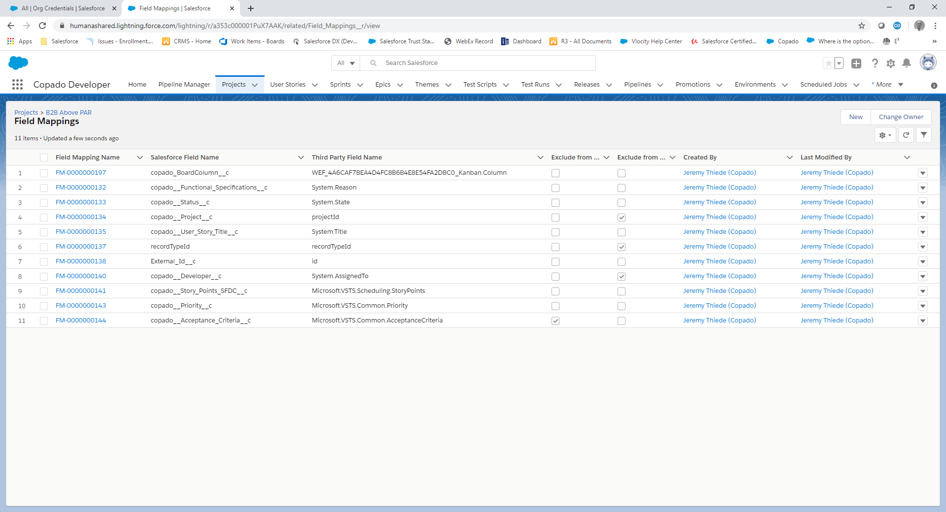
If the field you are looking for is not listed above, you can reference this URL here for Azure fields. If you are in need of Copado fields, please look in Salesforce at the User Story object.
Row 1 above is only needed if the project team wants Copado to sync where the User Story is in the pipeline and the scrum team uses the Kanban board in Azure Boards. Currently only B2B is using this additional sync functionality.
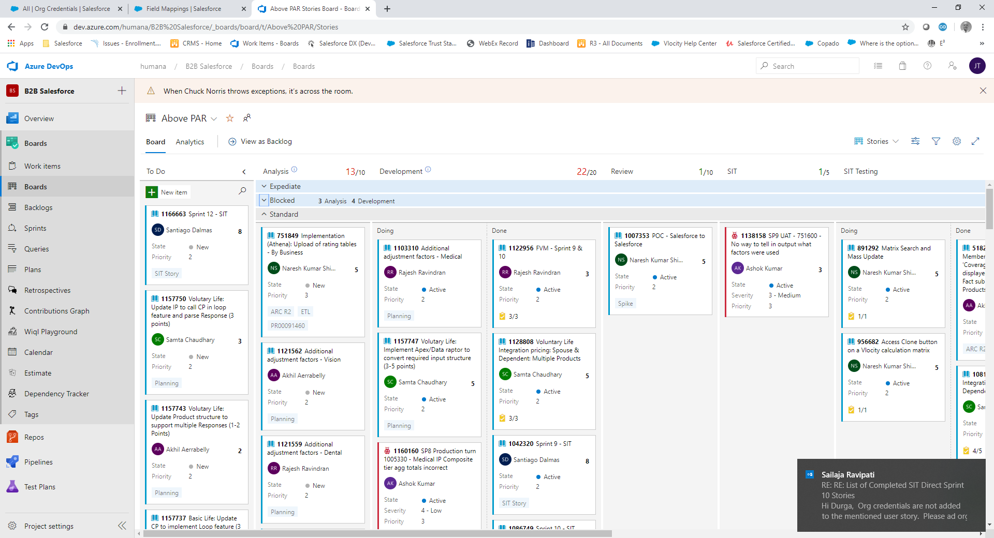

Setting Up Copado to Update Azure Kanban Columns
For example, if a User Story is currently in ‘Development’ on a board column like story 1122956 (see example above). When the User Story in Copado is moved to the SIT environment successfully, Copado will reach out to Azure and place the story in the ‘SIT’ column. If Row 1 (the mapping between the Kanban Column and Azure) did not exist, this functionality would not work.

You will also notice that Row 1’s value for the ‘Third Party Field Name’ is very long and unique. This field name can be determined by navigating to this URL:
https://dev.azure.com/humana/B2B%20Salesforce/_apis/wit/workitems/1122956?api-version=5.0
The URL above relates to a different Azure project and may need to be customized by you in order to see the correct fields. The green highlight is the name of the Azure project and should match that in an Azure URL. The yellow highlight is a work item number (the user story).
Below is an example of the returned JSON which lists the column name necessary for the board. There are two columns, one is named ‘System.BoardColumn’ and the other has the long name that begins with three letters, then a quid, then Kanban.Column. ‘System.BoardColumn’ is read only and will not work. The long Kanban column should be used. Each query setup in Azure will have a distinct Kanban column to be setup per project in Copado.

